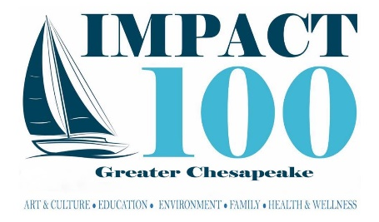

APPLICATION CHECKLIST
**The application and all required attachments, are due by June 30, 11:59PM ET.
Late submissions will not be considered.**

☐Complete the Impact100 Greater Chesapeake Grant Application via Google Forms
☐Email the required attachments below to grants@impact100greaterchesapeake.org. On the subject line of the email, indicate 2023GrantApplication, the focus area for which you are applying, and your organization name (e.g., 2023GrantApplication_FocusArea_ OrganizationName). Please use the same naming convention for all attachments (e.g., 2023GrantApplication_FocusArea_ OrganizationName_NameofAttachement).
☐501(c)(3) letter
☐Copy of the organization's Letter of Good Standing from Maryland, or proof that the
organization is in good standing (if a copy cannot be obtained in time)
☐Tax Form 990
☐Excel sheet of the program/project expenses using the required template. Reference
the example within the template, if needed. Include anticipated funding for your program/project, such as earned revenue, in-kind donations, support, special events, fundraisers, etc. The total expenses for the program/project must equal or exceed the amount of the Impact100 Greater Chesapeake grant.
☐Quotes or estimates to support the program/project expenses
☐Year to date budget for the current fiscal/calendar year
☐Balance sheet for the two most recent completed fiscal years
☐Income statement for the two most recent completed fiscal years
☐Letter of commitment from collaborating organizations, if applicable

